**STEPS TO PARTICIPATE IN THE CRA MEETINGS**

via LiveToAir option (i.e. make public comment,

or present/speak on an agenda item)

Please see the steps below to use the PARTICIPATE via LiveToAir option (i.e. make public comment, or present/speak on an agenda item) for the CRA meetings:



Step 1

To **PARTICIPATE** in the meeting via LiveToAir (i.e. make public comment, or present/speak on an agenda item), please use the link provided on the CRA’s Website for each meeting: <https://www.boyntonbeachcra.com/about-bbcra/meeting-agendas-minutes/bbcra-board-meeting-agendas-minutes>

Step 2 – Once prompted, you MUST provide access to your devices microphone AND camera in order to speak.

NOTE: Camera view MUST BE horizontal.

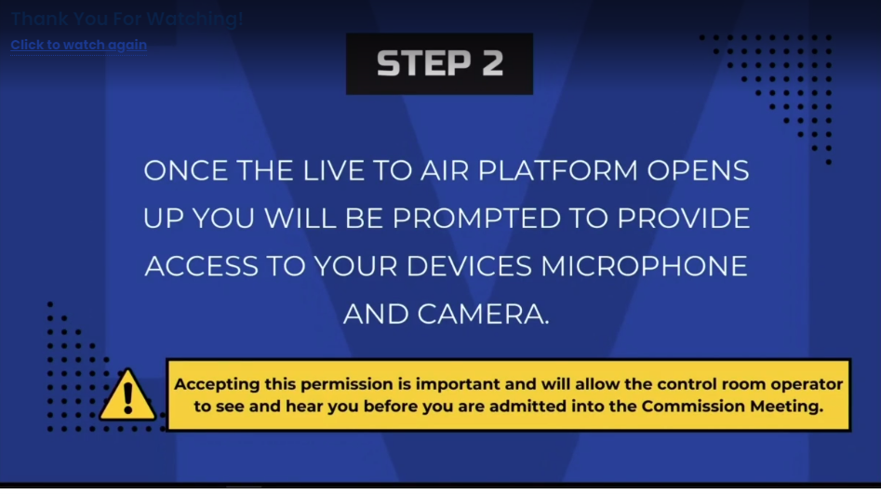

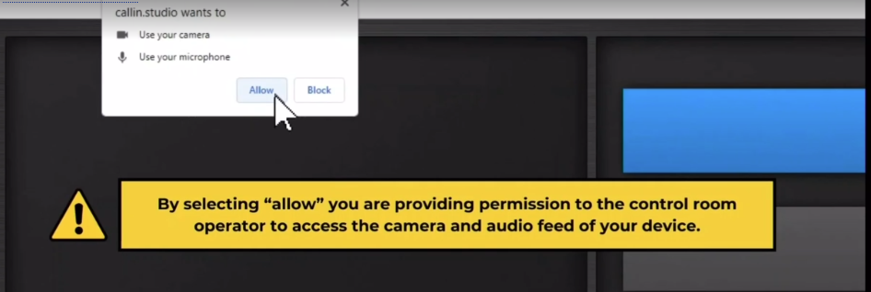

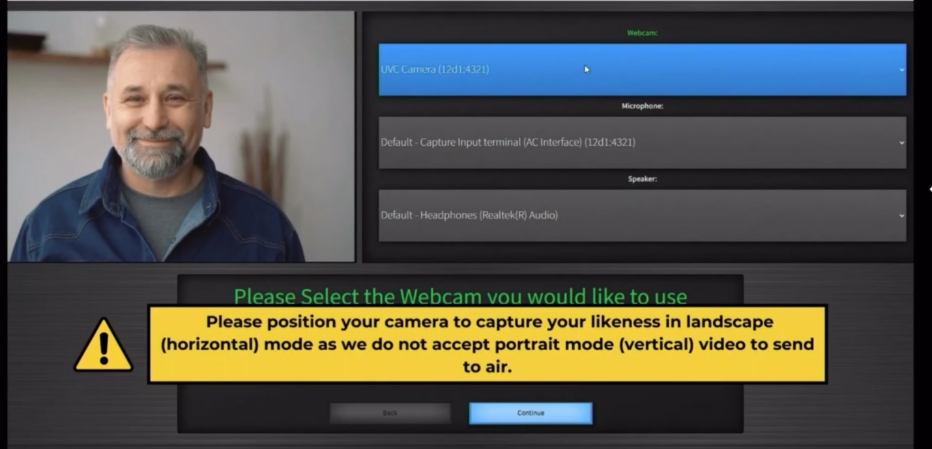

Step 3 – The meeting operator will speak to you and ask which agenda item you are there to speak about.

Note: Please respond to the operator as that allows them to get you in the proper queue for the meeting.

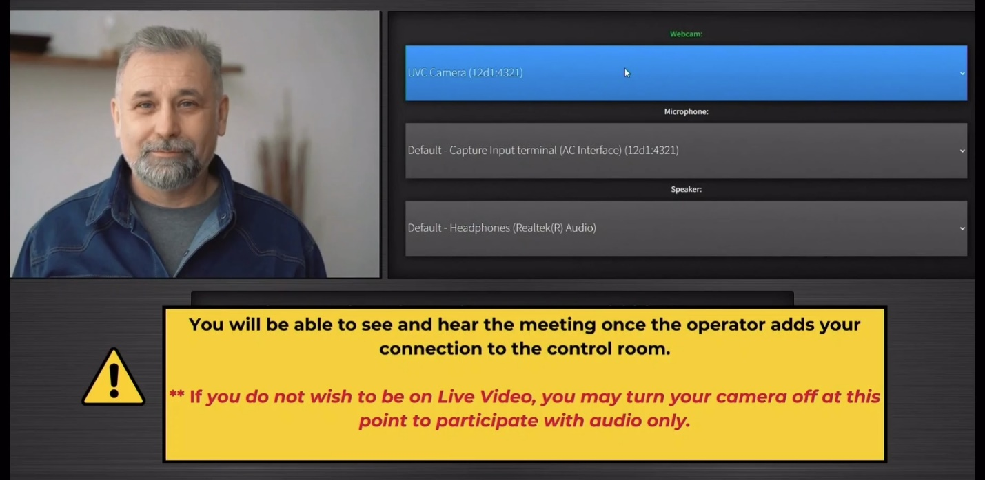

Step 4 – Please do not walk away from your device until your agenda item is complete.

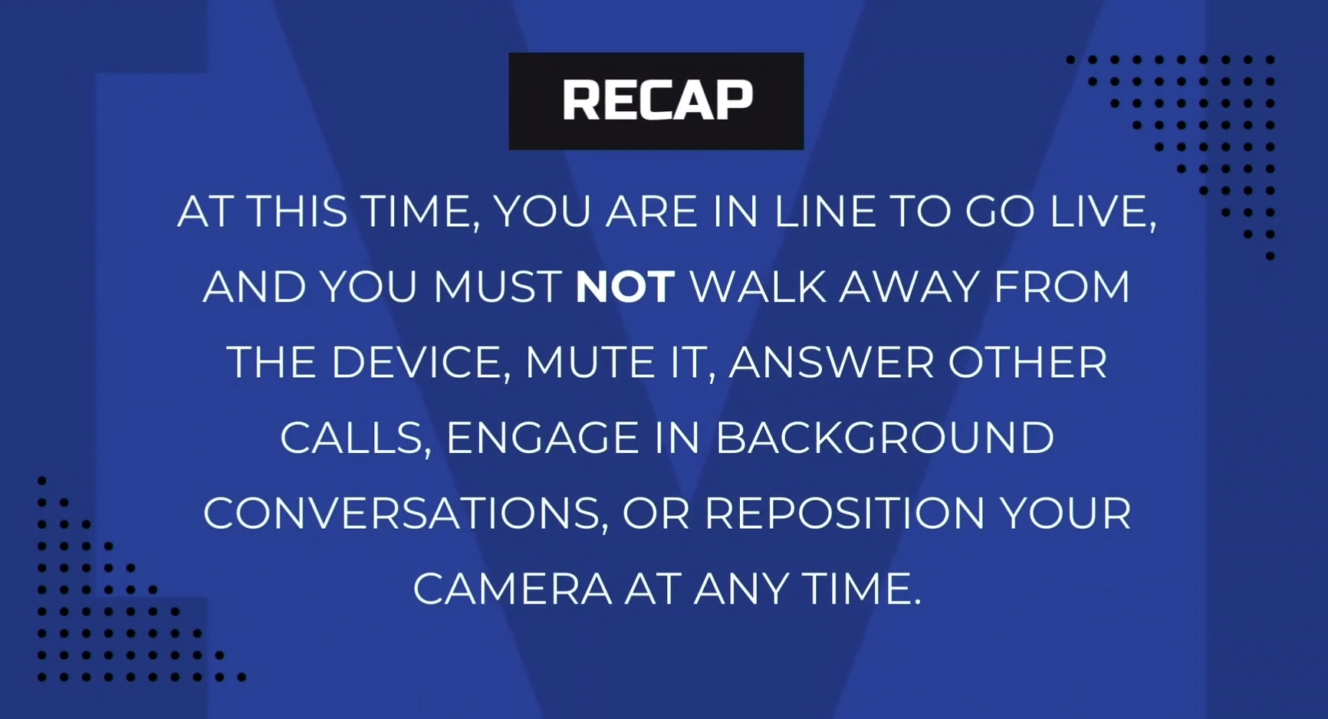

Thank you.